Semantic Segmentation

Semantic segmentation is currently one in all the high-level activities that opens the method for optimum information of the atmosphere. Semantic segmentation, in this it doesn't anticipate any bounding boxes around the objects, is distinct from object detection.

The method of classifying each pixel belonging to a specific label is semantic segmentation (e.g., sky, ocean, car, pedestrian, road, etc.)

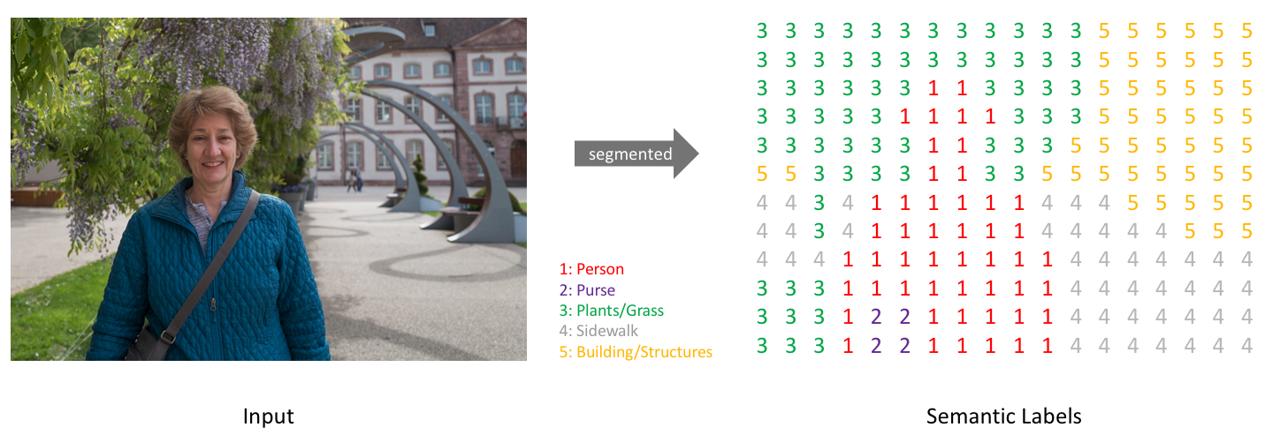

Image source: jeremyjordan.me

Inside a picture of multiple entities, we have a tendency to wish which pixel corresponds to which object. As an example, we are able to section the sky, land, trees, humans, etc. in an outdoor image.

**Semantic segmentation applications include:**

**Autonomous vehicles**

Autonomous vehicles could learn from segmentation, like self-driving cars and drones.⠀

**Analysis of a satellite image**

In order to section numerous types of ground, aerial photos will be used. It's also possible to do automated land mapping.

**Medical pictures**

Automated body scan segmentation could assist physicians in conducting screening procedures. as an example, models ar trained for growth detection.

A number of deep neural network architectures for semantic segmentation are discovered over the years. A Fully Convolution Network could be a network that within the original image categorizes each pixel. By providing an input image and label image, the network is trained. The label image has the same size dimensions as the input image with each pixel identifying an object class that represents the corresponding pixel in the input image. When the network is trained, the output of the network represents the possibilities for every pixel to be a locality of the given object category. As an example, if AN FCN is learned to work out for a given set of N input pixels between non-road and road pixels, then the FCN output are a 2*N dimensional vector with every picture element likelihood describing a part of a road or non-road area.

**Architecture of linguistics Segmentation for Autonomous Cars**

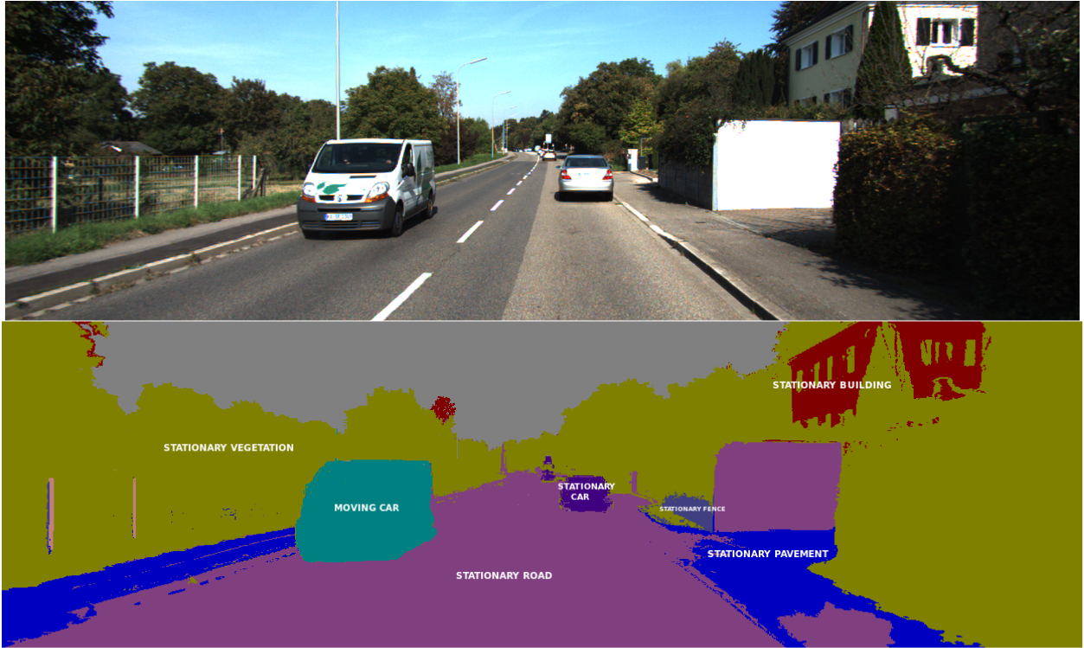

Image Source: https://wiki.tum.de/display/lfdv/Image+Semantic+Segmentation